Suicide Rates Overview¶

This kernel is made to check the relationship between suicide and many other factors.
- Data
- Data Cleaning
- Relationship with suicide
- Conclusion
- Reference
# for some basic operations
import numpy as np
import pandas as pd
import matplotlib.pyplot as plt
import seaborn as sns

# re(=regular expression operations) for changing string to float
import re

Data:
There is only one file provided in the dataset, as described below:
- master.csv : country, year, sex, age group, count of suicides, population, suicide rate, country-year composite key, HDI for year, gdpforyear, gdppercapita, generation (based on age grouping average).
# reading the data for Suicide Rates

df = pd.read_csv('../input/suicide-rates-overview-1985-to-2016/master.csv')

# checking the head of the data

df.head(10)
 | country | year | sex | age | suicides_no | population | suicides/100k pop | country-year | HDI for year | gdp_for_year ($) | gdp_per_capita ($) | generation
0 | Albania | 1987 | male | 15-24 years | 21 | 312900 | 6.71 | Albania1987 | NaN | 2,156,624,900 | 796 | Generation X
1 | Albania | 1987 | male | 35-54 years | 16 | 308000 | 5.19 | Albania1987 | NaN | 2,156,624,900 | 796 | Silent
2 | Albania | 1987 | female | 15-24 years | 14 | 289700 | 4.83 | Albania1987 | NaN | 2,156,624,900 | 796 | Generation X
3 | Albania | 1987 | male | 75+ years | 1 | 21800 | 4.59 | Albania1987 | NaN | 2,156,624,900 | 796 | G.I. Generation
4 | Albania | 1987 | male | 25-34 years | 9 | 274300 | 3.28 | Albania1987 | NaN | 2,156,624,900 | 796 | Boomers
5 | Albania | 1987 | female | 75+ years | 1 | 35600 | 2.81 | Albania1987 | NaN | 2,156,624,900 | 796 | G.I. Generation
6 | Albania | 1987 | female | 35-54 years | 6 | 278800 | 2.15 | Albania1987 | NaN | 2,156,624,900 | 796 | Silent
7 | Albania | 1987 | female | 25-34 years | 4 | 257200 | 1.56 | Albania1987 | NaN | 2,156,624,900 | 796 | Boomers
8 | Albania | 1987 | male | 55-74 years | 1 | 137500 | 0.73 | Albania1987 | NaN | 2,156,624,900 | 796 | G.I. Generation
9 | Albania | 1987 | female | 5-14 years | 0 | 311000 | 0.00 | Albania1987 | NaN | 2,156,624,900 | 796 | Generation X
# show the brief information about df DataFrame

df.info()
<class 'pandas.core.frame.DataFrame'>
RangeIndex: 27820 entries, 0 to 27819
Data columns (total 12 columns):
# Column Non-Null Count Dtype
--- ------ -------------- -----
0 country 27820 non-null object
1 year 27820 non-null int64
2 sex 27820 non-null object
3 age 27820 non-null object
4 suicides_no 27820 non-null int64
5 population 27820 non-null int64
6 suicides/100k pop 27820 non-null float64
7 country-year 27820 non-null object
8 HDI for year 8364 non-null float64
9 gdp_for_year ($) 27820 non-null object
10 gdp_per_capita ($) 27820 non-null int64
11 generation 27820 non-null object
dtypes: float64(2), int64(4), object(6)
memory usage: 2.5+ MB

Data Cleaning
# check is there any null object in it

df.isnull().sum()
country 0
year 0
sex 0
age 0
suicides_no 0
population 0
suicides/100k pop 0
country-year 0
HDI for year 19456
gdp_for_year ($) 0
gdp_per_capita ($) 0
generation 0
dtype: int64
# delete 'HDI for year' column to remove null object

df = df.drop('HDI for year', axis=1)
# change the name of the columns for easy usage

df=df.rename(columns={'country':'Country','year':'Year','sex':'Gender','age':'Age','population':'Population','suicides_no':'NumOfSuicides', 'suicides/100k pop':'SuicidesPer100k',
'country-year':'CountryYear',' gdp_for_year ($) ':'GdpForYear','gdp_per_capita ($)':'GdpPerCapital','generation':'Generation'})
# sort the age
df['Age'] = df['Age'].replace({'5-14 years': '1', '15-24 years': '2', '25-34 years': '3', '35-54 years': '4', '55-74 years': '5', '75+ years': '6'})

# change data type str to int for GdpForYear
df['GdpForYear'] = df['GdpForYear'].apply(lambda x : re.sub("[^\d\.]", "", x))
df['GdpForYear'] = df['GdpForYear'].astype('double')
# check after finishing data cleaning
df.head()
 | Country | Year | Gender | Age | NumOfSuicides | Population | SuicidesPer100k | CountryYear | GdpForYear | GdpPerCapital | Generation
0 | Albania | 1987 | male | 2 | 21 | 312900 | 6.71 | Albania1987 | 2.156625e+09 | 796 | Generation X
1 | Albania | 1987 | male | 4 | 16 | 308000 | 5.19 | Albania1987 | 2.156625e+09 | 796 | Silent
2 | Albania | 1987 | female | 2 | 14 | 289700 | 4.83 | Albania1987 | 2.156625e+09 | 796 | Generation X
3 | Albania | 1987 | male | 6 | 1 | 21800 | 4.59 | Albania1987 | 2.156625e+09 | 796 | G.I. Generation
4 | Albania | 1987 | male | 3 | 9 | 274300 | 3.28 | Albania1987 | 2.156625e+09 | 796 | Boomers

Function for Visualization
By defining function, it will help to avoid writing same code. This function set x&y axis, name for each axis and title and the size of graph.
def visualization(Title = None, xlabel = None, ylabel= None, xTitle= None):
fig = plt.figure()
plt.style.use(['fivethirtyeight'])
axes = fig.add_axes([0.3, 0.1, 1, 0.8])
if Title == 'Year & Suicides':
axes.plot(xlabel, ylabel, color = 'navy', linewidth=3, ls='--')
elif Title == 'Gender & Suicides':
axes.bar(xlabel, ylabel, color = ['crimson', 'navy'], linewidth=3)
else:
axes.bar(xlabel, ylabel, color = 'navy', linewidth=3)
axes.set_xlabel(xTitle, fontsize=12)
axes.set_ylabel('SucidiesPer100k', fontsize=12)
axes.set_title(Title, fontsize=15)
if Title == 'Age & Suicides':
plt.xticks(fontsize=10.5)
axes.set_xticklabels(('5-14 years', '15-24 years', '25-34 years', '35-54 years', '55-74 years', '75+ years'))
if Title == 'Gender & Suicides':
plt.xticks(fontsize=15)
return axes

Show relationship with Suicide
I will use 5 columns to show relationship with Suicide(NumOfSuicides, SucidiesPer100k)

- Year

- Age

- GdpForYear

- Generation

- Gender

1. Year
# make new DataFrame call 'df_year', which contains only 'Year', 'NumOfSuicides', 'Population', 'SucidiesPer100k'

df_year = df.drop(['Country', 'Gender', 'Age', 'CountryYear', 'GdpForYear', 'GdpPerCapital', 'Generation'], axis=1)

# group data based on Year

year_group = df_year.groupby(['Year'], as_index=False).sum()

# reset the SucidiesPer100k
year_group['SucidiesPer100k'] = (year_group['NumOfSuicides'] / year_group['Population']) * 100000

year_group.head()
 | Year | NumOfSuicides | Population | SuicidesPer100k | SucidiesPer100k
0 | 1985 | 116063 | 1008600086 | 6811.89 | 11.507336
1 | 1986 | 120670 | 1029909613 | 6579.84 | 11.716562
2 | 1987 | 126842 | 1095029726 | 7545.45 | 11.583430
3 | 1988 | 121026 | 1054094424 | 7473.13 | 11.481514
4 | 1989 | 160244 | 1225514347 | 8036.54 | 13.075653
year_visualization = visualization(Title= 'Year & Suicides',xlabel=year_group['Year'], ylabel=year_group['SucidiesPer100k'], xTitle='Year')
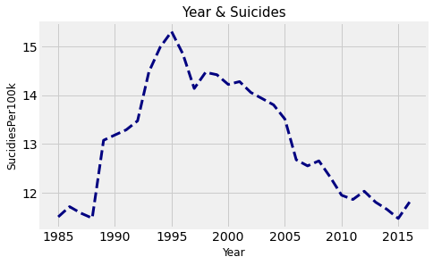

2. Age
# make new DataFrame call 'df_year', which contains only 'Age', 'NumOfSuicides', 'Population', 'SucidiesPer100k'

df_age = df.drop(['Country', 'Gender', 'Year', 'CountryYear', 'GdpForYear', 'GdpPerCapital', 'Generation'], axis=1)

# group data based on Age

age_group = df_age.groupby(['Age'], as_index=False).sum()

# reset the SucidiesPer100k
age_group['SuicidesPer100k'] = (age_group['NumOfSuicides'] / age_group['Population']) * 100000

age_group.head()
 | Age | NumOfSuicides | Population | SuicidesPer100k
0 | 1 | 52264 | 8398693237 | 0.622287
1 | 2 | 808542 | 8642946896 | 9.354934
2 | 3 | 1123912 | 8438103587 | 13.319486
3 | 4 | 2452141 | 14375888123 | 17.057318
4 | 5 | 1658443 | 8803245340 | 18.838996
age_visualization = visualization(Title= 'Age & Suicides',xlabel=age_group['Age'], ylabel=age_group['SuicidesPer100k'], xTitle='Age')
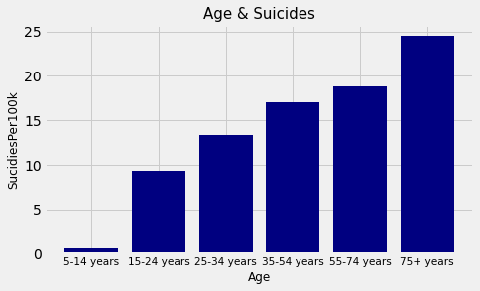

3. GdpForYear
# make new DataFrame call 'df_year', which contains only 'GdpForYear', 'NumOfSuicides', 'Population', 'SucidiesPer100k'

df_GDP = df.drop(['Country', 'Gender', 'Age', 'CountryYear', 'Year', 'GdpPerCapital', 'Generation'], axis=1)

df_GDP.info()
<class 'pandas.core.frame.DataFrame'>
RangeIndex: 27820 entries, 0 to 27819
Data columns (total 4 columns):
# Column Non-Null Count Dtype
--- ------ -------------- -----
0 NumOfSuicides 27820 non-null int64
1 Population 27820 non-null int64
2 SuicidesPer100k 27820 non-null float64
3 GdpForYear 27820 non-null float64
dtypes: float64(2), int64(2)
memory usage: 869.5 KB
print("The number of unique value in GdpForYear: ",len(df_GDP['GdpForYear'].unique()))
# check minimum & maximum value in GdpForYear
print("Minimum value in GdpForYear: ", df_GDP['GdpForYear'].min())
print("Maximum value in GdpForYear: ", df_GDP['GdpForYear'].max())
The number of unique value in GdpForYear: 2321
Minimum value in GdpForYear: 46919625.0
Maximum value in GdpForYear: 18120714000000.0
# since the number of GdpForYear is to large, I will make a new column call 'GdpForYearPer$1M', which divides data with 1,000,000(=$1M)
df_GDP['GdpForYearPer$1M'] = df_GDP['GdpForYear'].apply(lambda x : x /1000000)

# sort the data in GdpForYearPer$1M
df_GDP = df_GDP.sort_values(by=['GdpForYearPer$1M'])

# set the range of GdpForYearPer$1M

range_GDP = {'$0 ~ $100M': np.arange(0,100), '$100M ~ $1B': np.arange(100.0000001,1000), '$1B ~ $10B': np.arange(1000.000001, 10000), '$10B ~ $100B': np.arange(10000.000001, 100000),
'$100B ~ $1T': np.arange(100000.000001, 1000000), '$1T ~': np.arange(1000000.000001, 20000000)}

# generate "cuts" (bins) and associated labels from `range_GDP`.

cut_data = [(np.min(v), k) for k, v in range_GDP.items()]
bins, labels = zip(*cut_data)

# bins required to have one more value than labels
bins = list(bins) + [np.inf]
df_GDP['GdpForYearPer$1M'] = pd.cut(df_GDP['GdpForYearPer$1M'], bins=bins, labels=labels)

# drop GdpForYear column
df_GDP = df_GDP.drop('GdpForYear', axis=1)

# check the data
df_GDP.head()
 | NumOfSuicides | Population | SuicidesPer100k | GdpForYearPer$1M
14082 | 0 | 481 | 0.00
# group data based on GdpForYear

GDP_group = df_GDP.groupby(['GdpForYearPer$1M'], as_index=False).sum()

# reset the SucidiesPer100k
GDP_group['SuicidesPer100k'] = (GDP_group['NumOfSuicides'] / GDP_group['Population']) * 100000

GDP_group.head()
 | GdpForYearPer$1M | NumOfSuicides | Population | SuicidesPer100k
0
GDP_visualization = visualization(Title= 'GDP & Suicides',xlabel=GDP_group['GdpForYearPer$1M'], ylabel=GDP_group['SuicidesPer100k'], xTitle='GdpForYearPer$1M')
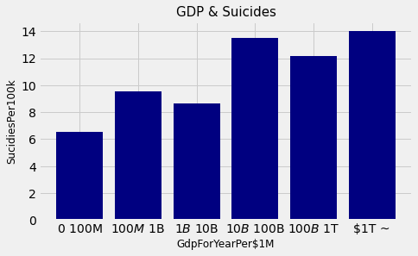

4. Generation
# make new DataFrame call 'df_Gene', which contains only 'Generation', 'NumOfSuicides', 'Population', 'SucidiesPer100k'

df_Gene = df.drop(['Country', 'Gender', 'Age', 'CountryYear', 'Year', 'GdpPerCapital', 'GdpForYear'], axis=1)

# group data based on Generation

Gene_group = df_Gene.groupby(['Generation'], as_index=False).sum()

# reset the SucidiesPer100k
Gene_group['SuicidesPer100k'] = (Gene_group['NumOfSuicides'] / Gene_group['Population']) * 100000

Gene_group.head()
 | Generation | NumOfSuicides | Population | SuicidesPer100k
0 | Boomers | 2284498 | 13350511729 | 17.111689
1 | G.I. Generation | 510009 | 2126202724 | 23.986847
2 | Generation X | 1532804 | 13472109292 | 11.377610
3 | Generation Z | 15906 | 2503541842 | 0.635340
4 | Millenials | 623459 | 10649461202 | 5.854371
Sort data by following years order
- G.I. Generation = 1901 ~ 1945
- Boomers = 1946 ~ 1964
- Generation X = 1965 ~ 1976
- Millenials = 1977 ~ 1995
- Generation Z = 1996 ~ TBD
# put Generation column to index for reordering

Gene_group = Gene_group.set_index('Generation')

# make order list for Generation
reorderlist = ['G.I. Generation', 'Boomers', 'Generation X', 'Millenials', 'Generation Z']

# reorder the Generation
Gene_group = Gene_group.reindex(reorderlist)

# put Generation index into column
Gene_group = Gene_group.reset_index()

# check the DataFrame
Gene_group.head()
 | Generation | NumOfSuicides | Population | SuicidesPer100k
0 | G.I. Generation | 510009 | 2126202724 | 23.986847
1 | Boomers | 2284498 | 13350511729 | 17.111689
2 | Generation X | 1532804 | 13472109292 | 11.377610
3 | Millenials | 623459 | 10649461202 | 5.854371
4 | Generation Z | 15906 | 2503541842 | 0.635340
Gene_visualization = visualization(Title= 'Generation & Suicides',xlabel=Gene_group['Generation'], ylabel=Gene_group['SuicidesPer100k'], xTitle='Generation')
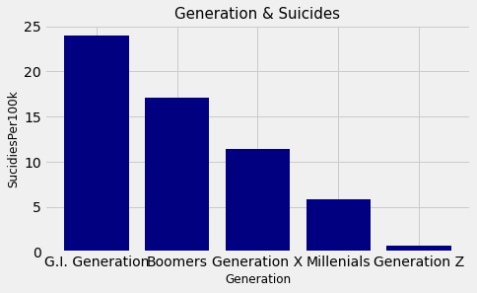

5. Gender
# make new DataFrame call 'df_gender', which contains only 'Gender', 'NumOfSuicides', 'Population', 'SucidiesPer100k'

df_gender = df.drop(['Country', 'Age', 'Year', 'CountryYear', 'GdpForYear', 'GdpPerCapital', 'Generation'], axis=1)

# group data based on Gender

gender_group = df_gender.groupby(['Gender'], as_index=False).sum()

# reset the SucidiesPer100k
gender_group['SuicidesPer100k'] = (gender_group['NumOfSuicides'] / gender_group['Population']) * 100000

gender_group.head()
 | Gender | NumOfSuicides | Population | SuicidesPer100k
0 | female | 1559510 | 26272781857 | 5.935839
1 | male | 5188910 | 25049376579 | 20.714727
gender_visualization = visualization(Title= 'Gender & Suicides',xlabel=gender_group['Gender'], ylabel=gender_group['SuicidesPer100k'], xTitle='Gender')
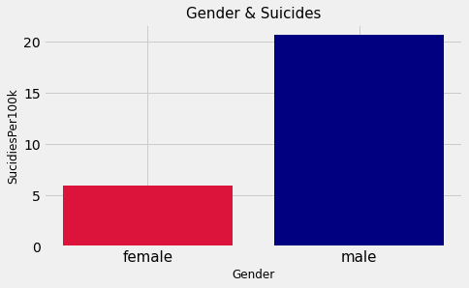

Conclusion
By comparing each useful columns(Year, Age, GdpForYear, Generation, Gender) to suicide, we have found out the features which affects people to suicide. There was one column that surprised me. In GdpForYear, if country has more than $1T GDP for year, it is likely to have high percentage for suicide. I guess people have more depression and Obsessive Compulsive Disorder. Higher GDP means the country is well developed and contain various technology. People needs to study and learn not only existence technology but also new skills. In addition, the gap between povery and wealth will be very serious problem. Rather than rich people, poor people will have less chance to succes. These problems will lead people to suicide.

